Web Version:
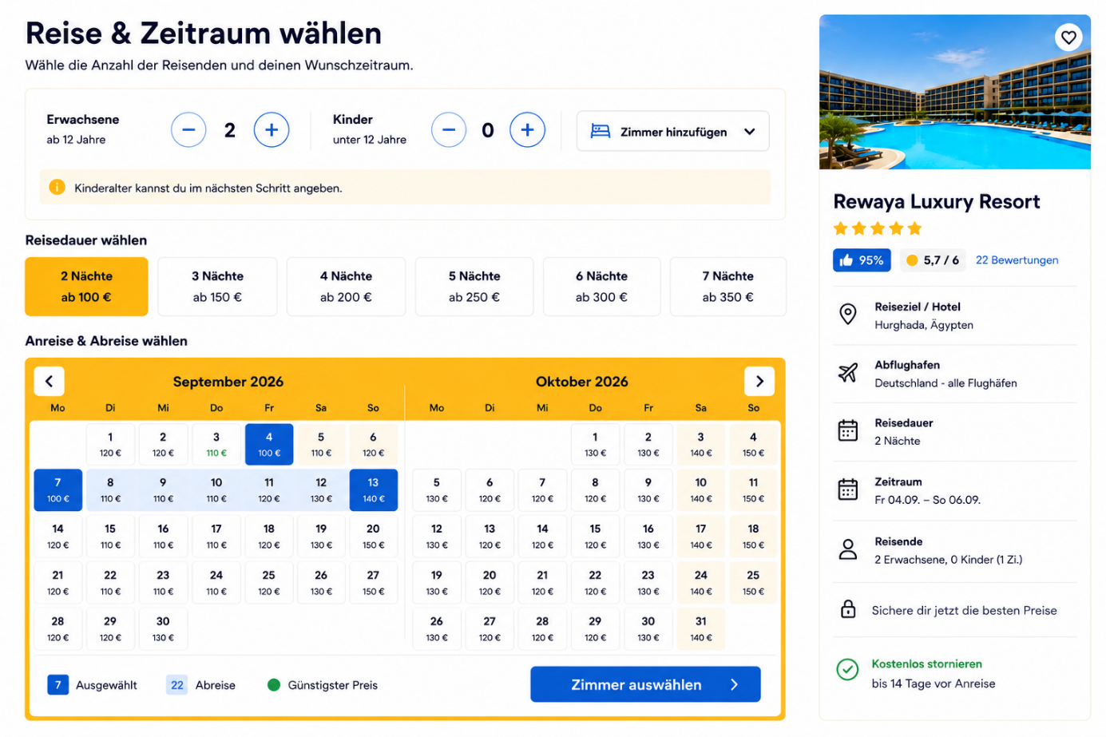
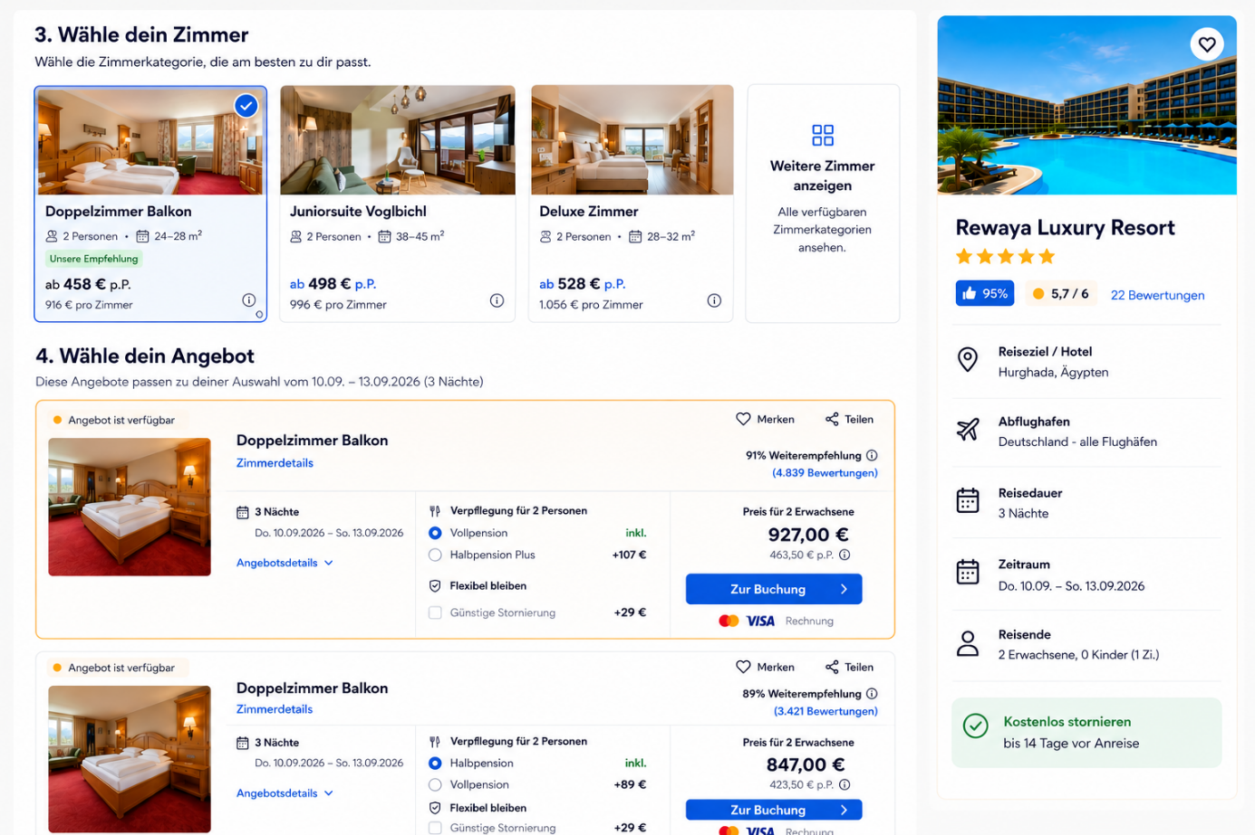
Mobile Version

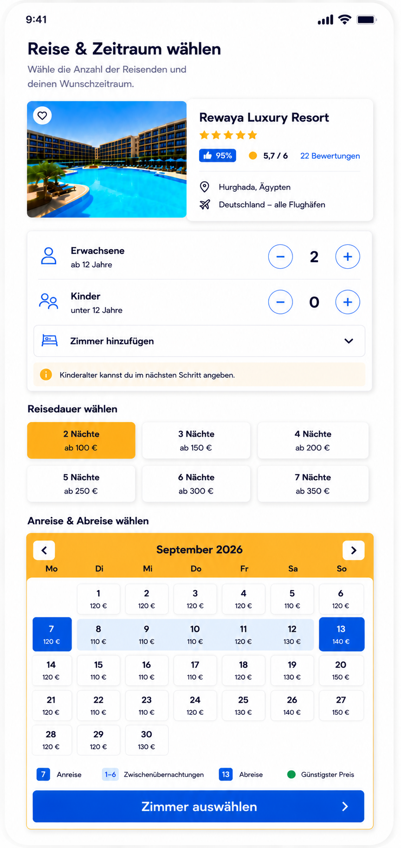
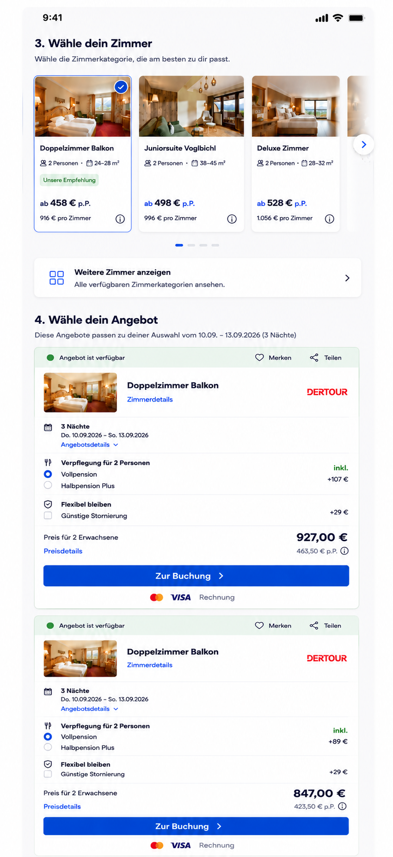
Custom Booking Flow – Functional Requirements
The booking flow itself will be in German for the customer.
The designs we have already created for desktop and mobile should be implemented as closely as possible to the provided mockups. We spent a lot of time refining the UI, so please do not redesign or reinterpret the booking interface.
This specification mainly explains the functionality, pricing logic and booking behavior behind the existing design.
1. Booking Flow
The customer should go through the following steps:
- Select travelers and number of rooms
- Select number of nights
- Select arrival date
- Optionally select a room category
- Select an offer
- Optionally upgrade meal plan / cancellation conditions
- Continue to booking
The selections in each step affect the availability and prices shown in the following steps.

2. Travelers & Number of Rooms
The customer first selects:
- Number of adults
- Number of children
- Age of each child
- Number of rooms
Example:
Room 1
- 2 adults
- 1 child
- Child age: 4
Room 2
- 2 adults
- 2 children
- Child ages: 2 and 8
The number and ages of travelers must be taken into account when calculating all prices shown later in the booking flow.

3. Number of Nights
After selecting the travelers, the customer selects the length of stay.
For example:
- 2 nights
- 3 nights
- 4 nights
- 5 nights
- 6 nights
- 7 nights
Each duration already displays a starting price, for example:
2 Nächte
ab 198 € p.P.
3 Nächte
ab 285 € p.P.
These prices must not be static.
As soon as the traveler configuration changes, the prices displayed for the different stay durations must be recalculated.
The displayed price should be the average price per person for that configuration.

4. Calendar & Automatic Departure Date
Once the customer has selected the number of nights, they only need to select the arrival date in the calendar.
The departure date must be calculated automatically.
Example:
Selected duration:
3 nights
Customer selects:
10 September 2026
The system automatically sets:
Arrival: 10 September 2026
Departure: 13 September 2026
The customer should not have to manually select the departure date.
In the UI:
- Arrival date = clearly highlighted
- Departure date = clearly highlighted
- Dates between arrival and departure = light blue
This should follow the calendar design from our final mockup.

5. Calendar Prices
Prices shown inside the calendar must dynamically reflect:
- Number of adults
- Number of children
- Ages of children
- Number of rooms
- Selected number of nights
- Room availability
- Applicable pricing rules
The displayed calendar price should represent the average price per person for the complete selected stay, starting on that particular arrival date.
So the price displayed on September 10 for a 3-night selection means:
Average price per person for a stay from September 10 to September 13.
It is not simply the price of the night of September 10.

6. Base Pricing Is Entered Per Night
In the backend/admin system, hotel prices are entered per night.
Example:
Validity:
01 September 2026 – 20 October 2026
Pricing:
Sunday – Thursday:
€100 per night
Friday – Saturday:
€120 per night
The system then calculates the total automatically depending on the selected stay.
Example:
3-night stay consisting of:
Thursday: €100
Friday: €120
Saturday: €120
Base total:
€340
The booking engine then applies occupancy rules, child discounts and any additional services.
The admin should also be able to override prices for individual dates or specific date ranges.

7. Child Pricing
Child pricing must be flexible.
Example configuration:
0 – 1.9 years
- Free
2 – 5.9 years
- 50% discount
OR alternatively:
- Fixed price, e.g. €50
6 – 11.9 years
- 25% discount
OR:
- Fixed price, e.g. €75
Therefore, the backend should support both:
Percentage-based child pricing
and
Fixed child pricing
Age ranges should ideally also be configurable.
The child's exact age selected at the beginning of the booking process determines which rule applies.

8. Average Price Per Person
Throughout the booking flow, we want to show the customer an easy-to-understand average price per person.
At offer level, however, both values must be displayed:
€458 p.P.
and
€916 total
For example:
2 adults + 1 child
Total booking price: €900
The system calculates the applicable prices for each traveler and then displays:
- Total price
- Average price per traveler
The backend should remain the source of truth for the calculation.

9. Selection Must Be Stored in the URL
The booking selection should be represented in the URL.
At minimum:
- Adults
- Children
- Child ages
- Number of rooms
- Number of nights
- Arrival date
- Departure date
Preferably also:
- Selected room category
- Meal plan
- Cancellation option
Conceptually:
/hotel/rewaya-luxury-resort
?adults=2
&children=1
&childAge=4
&rooms=1
&nights=3
&arrival=2026-09-10
&departure=2026-09-13
This is important so that:
- Refreshing the page keeps the selection
- Browser back/forward works correctly
- A configured booking can be shared
- Marketing links can open specific dates/durations
- The booking state is not lost unnecessarily
The URL parameters represent the selection, but they must never be trusted as the source for the final price.
Prices must always be recalculated server-side.

10. Room Category Selection
After the date selection, the customer sees the room categories.
Please follow the provided room-category design closely.
On mobile, this should be a horizontal slider/carousel.
Approximately 2.5 room cards should be visible at the same time so that the customer immediately understands that more rooms can be viewed by swiping horizontally.
Example:
Doppelzimmer Balkon
2 Personen · 24–28 m²
Unsere Empfehlung
ab 458 € p.P.
916 € pro Zimmer
The selected room category receives the blue selection state/checkmark shown in the mockup.

11. Room Category Selection Is Optional
The customer does not have to select a room category.
If no room category is selected:
→ Show offers from all available room categories.
If the customer selects:
Doppelzimmer Balkon
→ Only show offers matching that room category.
This makes the room-category section effectively an optional filter.

12. Unavailable Room Categories
A room category may be unavailable because of:
- Selected dates
- Inventory
- Number of adults
- Number of children
- Child ages
- Minimum occupancy
- Maximum occupancy
- Room configuration
Do not simply remove such rooms from the interface.
Keep the room card visible but display it in a disabled/grey state.
Clearly show:
Nicht verfügbar
Optionally, where we know the reason:
Für deine ausgewählte Belegung nicht verfügbar
or
Für diesen Zeitraum nicht verfügbar
The unavailable card must not be selectable.

13. Room Details
When the customer clicks:
Zimmerdetails
do not navigate to another page.
Open the room details directly on top of the current booking page.
Desktop:
- Modal / overlay
Mobile:
- Large bottom sheet or full-screen overlay
It can contain:
- Room name
- Image gallery
- Room size
- Maximum occupancy
- Bed configuration
- Balcony / terrace
- View
- Bathroom
- Air conditioning
- Wi-Fi
- Amenities
- Additional room information
When the customer closes it, they should return to exactly the same position and booking state.

14. Offers
Below the room categories comes:
4. Wähle dein Angebot
The design should follow our final offer-card mockup.
Important design details:
- Narrow/mobile-friendly card
- Light shadow
- Green dot next to “Angebot ist verfügbar”
- Very light green background behind the availability header
- Blue booking CTA
- Large and clearly readable price
- Room image
- Provider/organizer logo
- “Merken” and “Teilen”
- No hotel review score inside the offer card
- Keep the spacing and proportions from the approved mockup

15. Meal Plan Upgrade
Each offer has a base meal plan.
Example:
Verpflegung für 2 Personen
◉ Frühstück — inkl.
○ Frühstück & Abendessen — +107 €
The customer can optionally select the upgraded meal plan.
The total price and average price per person must update immediately without a page reload.
Different hotels/offers may support different meal plans, for example:
- Room only
- Breakfast
- Half Board
- Half Board Plus
- Full Board
- All Inclusive
- Ultra All Inclusive
The system therefore must not hard-code specific meal-plan types.

16. Cancellation Upgrade
Cancellation is another optional upgrade.
Example:
Flexibel bleiben
☐ Kostenlose Stornierung — +29 €
If selected:
- Total price updates
- Price per person updates
If free cancellation is already included:
Kostenlose Stornierung — inkl.
If no alternative cancellation option exists for the offer, do not display an upgrade option.

17. Offer Pricing
Every offer should clearly show both the total and per-person price.
Example:
Preis für 2 Erwachsene
927,00 €
463,50 € p.P.
For a family:
Preis für 2 Erwachsene + 1 Kind
1.240,00 €
413,33 € p.P.
The large amount should be the total booking price.
The smaller amount underneath is the average price per person.

18. Multiple Rooms
This part is particularly important.
If the customer selected more than one room at the beginning, the system must guide them through the selection room by room.
For example, if the customer selected 2 rooms:
Room 1 of 2
Show the traveler allocation for Room 1.
The customer selects:
- Room category
- Offer
- Meal plan
- Cancellation option
The CTA should clearly say:
1. Zimmer auswählen
After clicking it, Room 1 is saved and the interface continues to:
Room 2 of 2
The customer then selects the configuration for the second room.
CTA:
2. Zimmer auswählen
Only after all rooms have been configured should the customer continue to the final booking summary.
It must always be visually obvious which room is currently being configured.

19. Different Room Types Must Be Possible
Customers must be able to book different room categories within the same booking.
Example:
Room 1
Doppelzimmer Balkon
2 adults
Room 2
Deluxe Zimmer
2 adults + 1 child
The same applies to available optional extras if the underlying offer supports them.
Each room therefore needs its own independent booking configuration.

20. Multi-Room Price Calculation
Internally, the system needs to keep the price breakdown separate.
For example:
Room 1
€916
Room 2
€1,080
Total booking price
€1,996
Average per person
€399.20 p.P.
The pricing model should separately account for:
- Adult prices
- Child prices
- Individual room prices
- Meal supplements
- Cancellation supplements
- Other optional supplements
- Total booking price

21. Admin / Pricing Management
The admin interface should make it easy to create and maintain pricing rules.
A pricing rule should contain at least:
- Hotel
- Room category
- Valid from
- Valid until
- Applicable weekdays
- Price per night
- Occupancy / pricing basis
- Child pricing
- Minimum stay
- Maximum stay
- Inventory / availability
- Meal plan
- Cancellation options
Example configuration:
Hotel:
Rewaya Luxury Resort

Room category:
Doppelzimmer Balkon

Validity:
01.09.2026 – 20.10.2026

Sunday–Thursday:
€100 / night

Friday–Saturday:
€120 / night

Children:
0–1.99 years: Free
2–5.99 years: -50%
6–11.99 years: -25%

Alternative fixed-price configuration:
2–5.99 years: €50
6–11.99 years: €75

Minimum stay:
2 nights

Maximum stay:
7 nights
It should also be possible to override the standard weekday prices for individual dates or special periods.

22. Pricing Architecture
The backend must be the single source of truth for prices and availability.
Do not calculate or trust final booking prices purely in the frontend.
The frontend can send something conceptually like:
hotel
arrivalDate
numberOfNights

rooms: [
{
adults,
children: [ages],
roomCategory,
offer,
mealPlan,
cancellationOption
}
]
The backend should return something conceptually like:
availability
arrivalDate
departureDate

availableRoomCategories
availableOffers

roomPrice
adultPrice
childPrice
mealSupplement
cancellationSupplement

totalPrice
averagePricePerPerson
Whenever something price-relevant changes, such as:
- Travelers
- Child age
- Number of nights
- Arrival date
- Room category
- Meal plan
- Cancellation option
the relevant prices and availability should be recalculated.

Important Design Requirement
Please do not redesign the booking flow.
The latest provided desktop and mobile mockups are the visual reference.
In particular, keep:
- The light grey page background
- White cards with subtle shadows
- Blue primary buttons
- Orange calendar styling
- Light-blue selected date range
- Green availability dot
- Very light green availability background
- Current typography hierarchy
- Current spacing
- Current rounded corners
- Current room-card design
- Horizontal room-category slider on mobile
- Approximately 2.5 visible room-category cards on mobile
- Current narrow/vertical mobile offer cards
- Current price hierarchy
- Current wide “Zur Buchung” button
The website UI and all customer-facing text will be in German. This document is only written in English to explain the requirements to the development team.
The main objective now is to implement the booking and pricing logic behind the design we have already finalized, rather than creating a new UI.

23. Manual Pricing Now, API Integration Later
For the initial version, all hotel prices, availability rules, room categories, meal supplements, child discounts and cancellation options will be entered and managed manually in our backend/admin panel.
However, the system architecture must be designed so that we can later connect external APIs without rebuilding the booking flow.
The frontend and booking logic should therefore not depend directly on manually entered database fields.
Instead, there should be a clean pricing/availability layer between the frontend and the data source.
For Phase 1:
Frontend
↓
Booking / Pricing Service
↓
Our manually managed database
Later:
Frontend
↓
Booking / Pricing Service
↓
Hotel / Tour Operator / Booking API
Or even a combination:
Frontend
↓
Booking / Pricing Service
↓
Manual inventory
+ External APIs
+ Tour operator APIs
The goal is that the customer-facing booking flow remains exactly the same regardless of where the price and availability data comes from.
The API integration later may provide, for example:
- Live prices
- Live room availability
- Room categories
- Occupancy rules
- Child pricing
- Meal plans
- Cancellation conditions
- Supplements
- Minimum stay
- Maximum stay
- Booking conditions
The booking engine should normalize this information into our own internal structure before sending it to the frontend.
This is important because different providers will most likely return data in different formats.
We do not want the frontend to be built specifically around one provider's API.

24. Booking Parameters Must Be Shareable via URL
The booking URL must preserve the customer's main search parameters.
At minimum:
- Arrival date
- Departure date
- Number of nights
- Number of adults
- Number of children
- Age of each child
- Number of rooms
- Ideally traveler allocation per room
For example:
/hotel/rewaya-luxury-resort
?arrival=2026-09-10
&departure=2026-09-13
&nights=3
&adults=2
&children=1
&childAges=4
&rooms=1
For multiple rooms, the URL structure needs to support room-specific occupancy as well.
Conceptually:
?arrival=2026-09-10
&nights=3
&rooms=2
&room1Adults=2
&room1Children=1
&room1ChildAges=4
&room2Adults=2
&room2Children=0
The exact parameter structure can be decided by the developer, but it should be:
- Stable
- Human-readable where practical
- Shareable
- Backward-compatible
- Easy for external systems to generate
- Validated server-side
When a customer opens such a URL, the booking page should automatically preselect the correct:
- Traveler configuration
- Number of rooms
- Number of nights
- Arrival date
- Calculated departure date
and immediately load the correct prices and availability.

25. External Hotel Meta Search / Deep-Linking Compatibility
This is important for the future.
We want the booking system to be architected so that we can later send traffic from hotel metasearch and travel platforms such as:
- Google Hotels
- trivago
- Tripadvisor
- Other hotel/metasearch partners
The long-term goal is that when a customer searches on an external platform with, for example:
10 September 2026 – 13 September 2026
2 adults
1 room
and clicks through to our website, our booking page should already open with:
2 adults
1 room
3 nights
Arrival: 10.09.2026
Departure: 13.09.2026
preselected.
The user should not have to enter the same search information again.
Therefore, the booking flow needs a proper deep-link architecture from the beginning.
External parameters should be mapped into our internal booking state.
Conceptually:
External platform
↓
Deep link to our hotel page
↓
Read arrival / departure / occupancy parameters
↓
Validate parameters
↓
Create internal booking state
↓
Load current price + availability
↓
Display the matching booking configuration
Very important:
The price passed in a URL or by an external platform must never be blindly trusted.
When the customer lands on our website, our backend must recalculate and validate:
- Availability
- Current price
- Occupancy
- Child rules
- Room availability
- Length-of-stay restrictions
before showing a bookable offer.

26. Architecture Should Be Ready for Future Metasearch Feeds
Even if we do not implement Google Hotels, trivago or Tripadvisor integration in Phase 1, the data structure should be built with this future use case in mind.
In particular, hotels and offers should have stable internal identifiers for things such as:
- Hotel
- Room category
- Rate / offer
- Meal plan
- Cancellation policy
- Occupancy
- Currency
- Price
- Availability
This will make it much easier later to map our inventory to external hotel platforms.
For example, we should avoid identifying a room only by its visible German name such as:
Doppelzimmer Balkon
Instead, internally it should have a permanent identifier such as:
room_category_id: 1842
while the display name remains:
Doppelzimmer Balkon
The same principle should apply to hotels and rates.

27. Important Separation Between URL State and Booking Data
The URL should describe what the customer searched for, not contain trusted booking information.
For example:
arrival=2026-09-10
nights=3
adults=2
children=1
childAges=4
is fine.
But final calculated values such as:
price=927
should not be treated as authoritative.
The flow should always be:
URL parameters
→ Validate search parameters
→ Query pricing engine
→ Query availability
→ Calculate current price
→ Display result
This is especially important once external traffic starts coming from Google Hotels, trivago, Tripadvisor or API partners.

Additional architectural requirement
Please consider the booking system from the beginning as a booking engine with replaceable data sources, not simply as a page that reads manually entered prices.
Phase 1:
Manual prices and availability entered by us.
Phase 2:
Combination of manual data and external APIs.
Later:
Live pricing and availability from multiple providers, plus distribution to hotel metasearch platforms.
The customer-facing design should remain the same throughout these phases.
The work we are doing now should therefore create a foundation that allows us to add these integrations later without rebuilding the hotel pages or booking flow from scratch.

CHECKOUT:
Should Looks Like here in Desktop and Mobile:
https://www.holidaycheck.at/wbf/booking/6015df42-f723-4212-b60d-a0a5c916a23b?ctx=hotel-offerlist&hotelid=3a049b87-5928-3ca2-b344-73ab6c6df56c&hotelname=hotel-norica-thermenhotels-gastein&pos=3&sorting=recommendationPrice&tourOperator=HCT&travelkind=hotelonly

